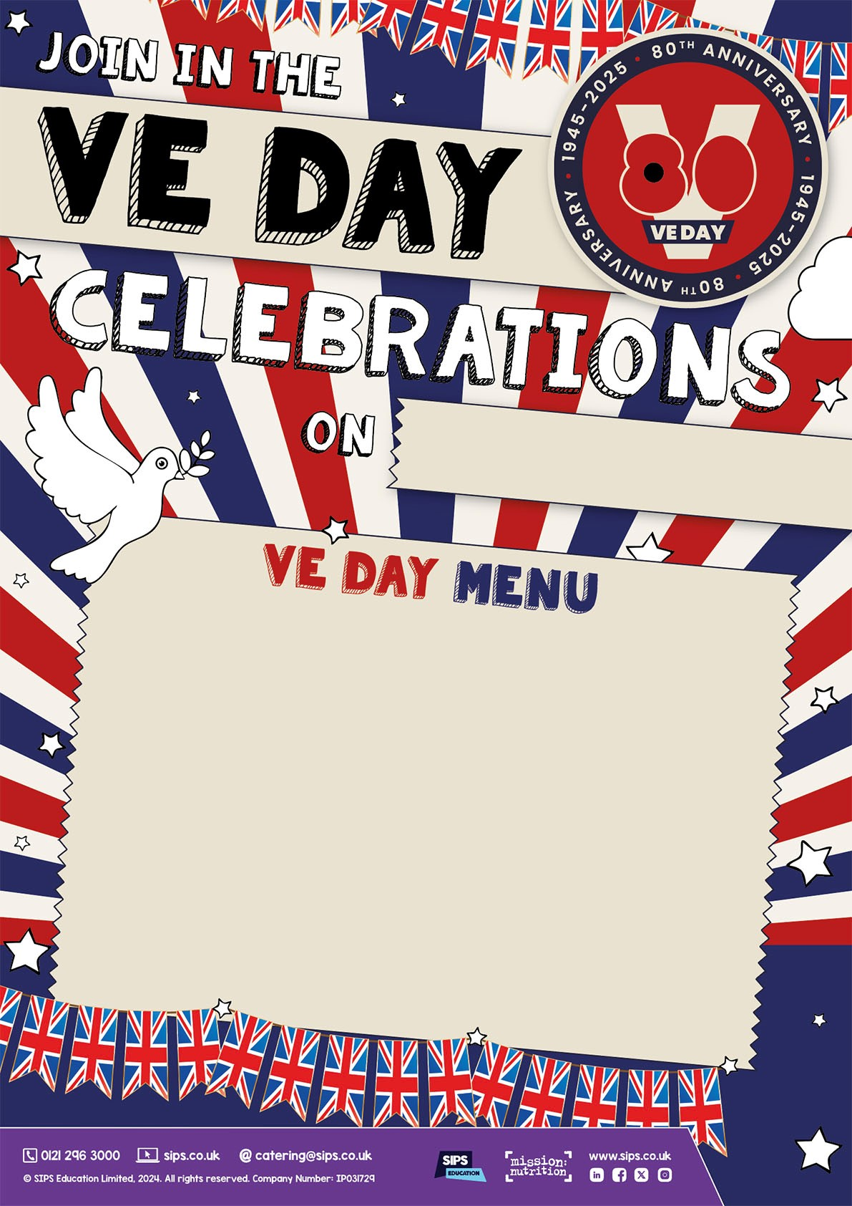

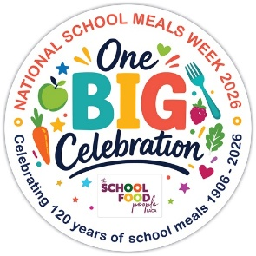

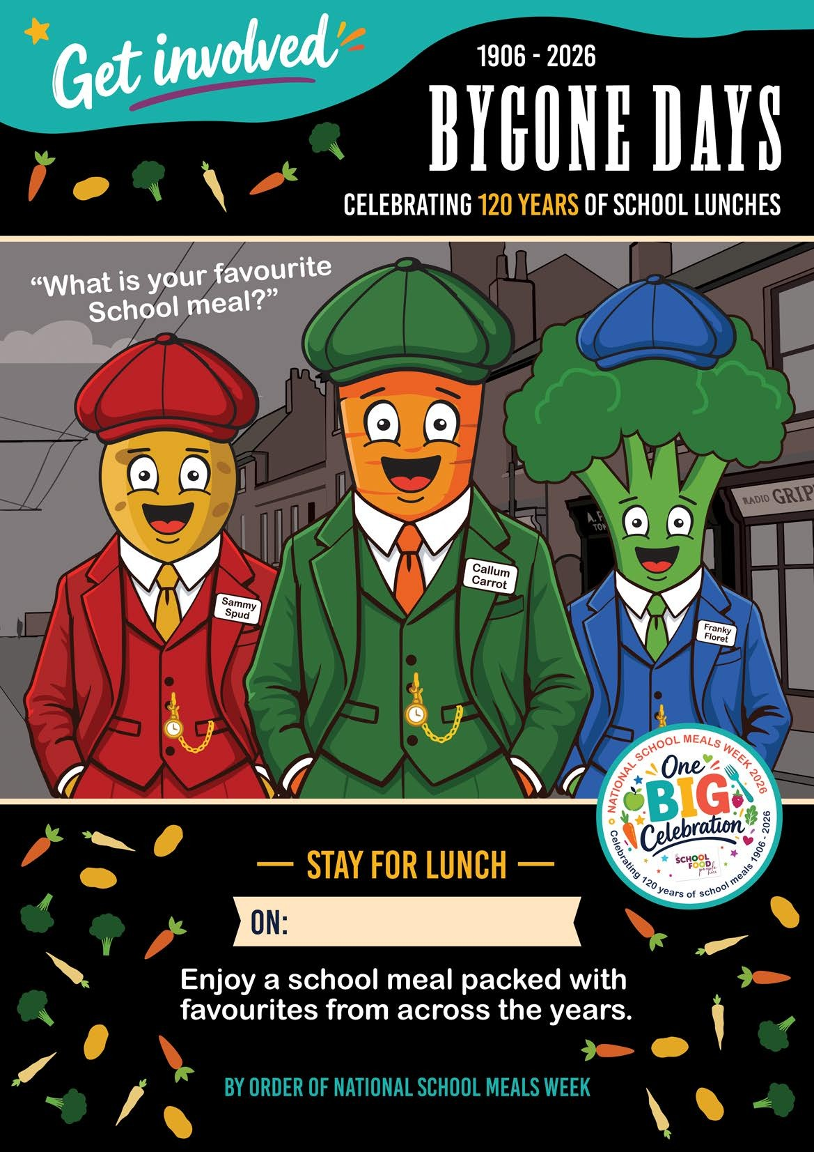
Roast Chicken Dinner
Quorn Vegan Fillet
******
Roast or Mashed Potatoes
Yorkshire Pudding
Sage & Onion Stuffing
Broccoli & Carrots
******
Chocolate Sponge & Pink Custard
Rice Pudding with Jam
On: Tuesday 10th November

